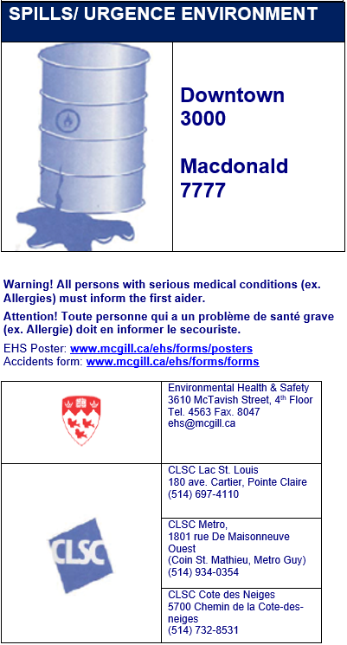
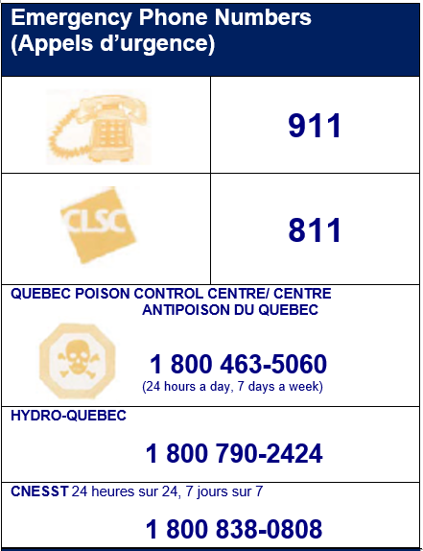
CNESST Certified First Aiders
(Secouristes qualifiés)
http://www.mcgill.ca/ehs/training/firstaid/certified
Last Name, First Name  (Nom, Prenom) | Tel. | Room or Lab or Picture
Last Name, First Name | tel.
First Aid Kits

(Trousses de premiers secours)
Room (Salle)
Automated External Defibrillator
(Défribrillateur Extreme Automatique)
http://www.mcgill.ca/ehs/training/firstaid/aed

Edifice/Room (Salle)

