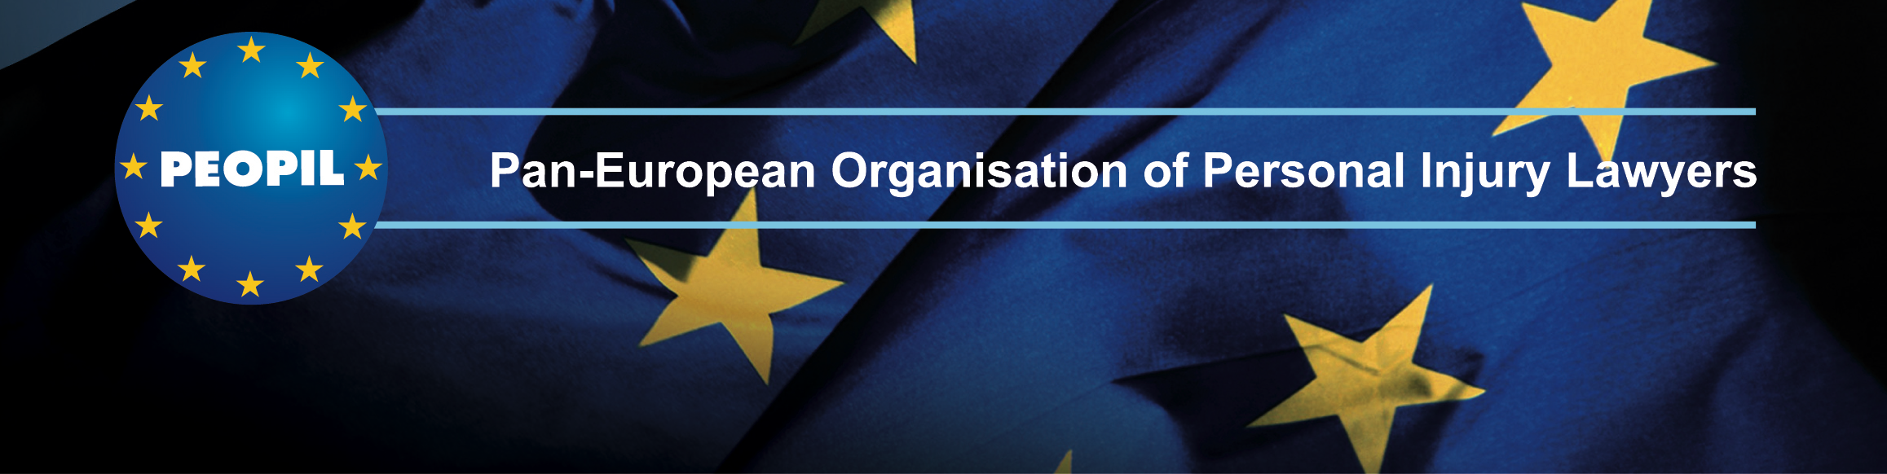

**McGill University/PEOPIL Conference on International Aviation Law & Insurance**

**[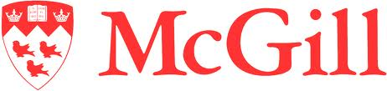](http://www.google.ca/imgres?q=mcgill+logo&hl=en&sa=X&rlz=1T4GGLR_enCA261CA262&biw=1242&bih=762&tbm=isch&prmd=imvns&tbnid=P8w_YpJ8kc0CHM:&imgrefurl=http://www.tsp.ece.mcgill.ca/Champagne/&docid=UB4GntajM1KycM&w=1306&h=309&ei=cwWCTtDrFYjt0gG8s_C4AQ&zoom=1)**

**McGill University/PEOPIL**

**Seventh Annual**

**CONFERENCE ON INTERNATIONAL AVIATION LAW & INSURANCE**

at

**The Law Society**

**113 Chancery Lane**

**London**

**APRIL 10-11, 2014**

**Sponsored by**

**The McGill University Institute of Air & Space Law**

**PEOPIL (Pan-European Organisation of Personal Injury Lawyers)**

**and the**

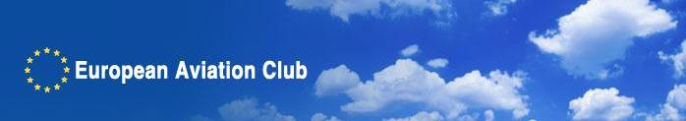

This event brings together world-leading aviation liability and insurance experts to address the following topics:

* **Recent Developments in Aviation Liability and Insurance**
* **Comparative Jurisprudence on the Montreal Convention of 1999**
* **Air Carrier Liability under Antitrust and Competition Laws**
* **Criminal Liability and Accident Investigations**
* **Consumer Protection Regulation**
* **Jurisdiction and *Forum Non Conveniens* Dismissals of Jurisdiction**

**Prior International Aviation Law & Insurance Conferences were held in:**

**Toulouse – 2008**

**Montreal – 2009**

**Amsterdam – 2010**

**Montreal 2011**

**London – 2012**

**Montreal - 2013**

**THURSDAY - APRIL 10, 2014**

**Networking Reception sponsored by**



Offices of Irwin Mitchell LLP, 40 Holborn Viaduct London

**FRIDAY – APRIL 11, 2014**

**PROGRAM**

**The Law Society**

**113 Chancery Lane**

**London**

**8:00 – 9:00 REGISTRATION**

**9:00 – 10:15**

**Air Carrier & Manufacturers’ Liability: Plaintiff’s and Defendant’s Perspectives**

* *Forum Non Conveniens* – Best Positioning for Foreign Air Crashes: A Case Study of *Lewis v Lycoming*
* Warsaw and Montreal Convention, Interpretations of “Accident” in Different Jurisdictions – Recent Cases
* Montreal Convention – Who are the Contracting and Actual Carriers?
* Air Carriers – Defining the Boundaries for Nervous Shock.
* A Comparative Analysis of the Montreal Convention Limitation Period in Different Jurisdictions.
* Recent Warsaw and Montreal Convention Interpretations - *West Caribbean Airways* Case Update.
* Manufacturers Liability, *Forum Non Conveniens* and Applicable Law – *Bashkirian* Case Update

**Chair:** Jim Morris - Irwin Mitchell LLP, London

**Speakers:**

* Dan Rose – Kreindler & Kreindler, New York
* Carlos Villacorta-Salís, Madrid
* David Wilcox – Clyde & Co., London

**10:15 – 10:35**

**Refreshment Break**

**10:35 – 12:00**

**Air Accidents & Criminal Investigations: The Rise of “Just Culture”**

* An international and comparative view of how different jurisdictions deal with corporate manslaughter and the rise of “just culture”
* Air Accidents & Criminal Investigations: The US and EU experience, with particular focus on the July 2000 Air France Concorde disaster
* The Admissibility of official accident reports in legal proceedings – the Common and Civil Law experience with specific examples from the UK, France and Spain.

**Chair:** James Healy-Pratt – Stewarts Law LLP, London

**Speakers:**

* Saturia Ortega Félix, Fernando Scornik Gerstein, Las Palmas de Gran Canaria, Spain
* Gerard Forlin, QC – London
* Fernand Garnault - Me Garnault Garnault Rembauville Bureau Tassy, Paris
* Vonnick Le Guillou - Bird & Bird, Paris

**12:00 – 13:00**

**LUNCH**

**13:00 – 14:15**

**Emerging Insurance Issues**

* Insuring UAVs (Unmanned Aerial Vehicles, or RPAS, Remotely Piloted Aircraft Systems)
* Aircraft Leasing, Insurance and Lessor Liability
* Emerging Case Law in the UK Affecting Defense of Aviation Insurance Claims
* Various Insurance/Reinsurance Issues from a US Perspective

**Chair:** Ulla Norrhäll – Munich Re, Munich

**Speakers:**

* Jean Fournier – Global Aerospace, Paris
* Marko Ninkovic – QBE, London
* Katherine B. Posner - Condon & Forsyth, New York
* Vanessa Williams - Mitsui Sumitomo Insurance (UK), London

**14:15 – 15:30**

**Passenger Rights: Regulators Run Amok?**

* The Proliferation of Consumer Protection Regulations
* EU Regulation 261 Revised
* Enforcement
* Passenger Rights and Airlines with Financial Difficulties

**Chair:** Mia Wouters – LVPlaw, Brussels

**Speakers:**

* Oleksi Burchevskyy – Wizz Air, Kyiv, Ukraine
* David Kendrick – UK Civil Aviation Authority, London
* Frederic Malaud – International Civil Aviation Organization, Montreal
* Catherine Pawluch – Davis, Toronto

**15:30 – 15:50**

**REFRESHMENT BREAK**

**15:50 – 17:00**

**How In-House Legal Counsel Manage Liability Claims**

* How do in-house counsels manage claims (e.g., selection of outside lawyers, management of outside lawyers, monitoring of legal fees)?
* What are their internal programs of training, and processing, monitoring, and resolving claims?
* How do they prepare themselves for liability cases (e.g., assessment of exposure, human resources issues, in-house training)?
* What are the differences in approaches to handling day-to-day claims vis-à-vis major aviation catastrophes?
* How do the insureds select, and interact with, insurers?
* How do in-house counsel educate management to avoid corporate liability?
* How do in-house counsel handle claims, interact with outside lawyers, set standards for reporting & invoicing, in-house training etc.?

**Chair:**  Sean Gates (Gates Aviation LLP, London, UK)

**Panelists:**

* Louise-Hélène Sénécal - Air Canada, Montreal
* Stéphanie Rostren - Airbus Helicopters, Marignane, France
* William F. Ranieri - USAIG, New York

**18:00 – 19:30**

**Networking Reception sponsored by:**

[http://subscriptions.clydeco.com/reaction/images/signatures/clyde_co.png](http://www.clydeco.com/)*Clyde & Co LLP, The St. Botolph Building, 138 Houndsditch, London, EC3A 7AG.*Map. <http://www.clydeco.com/offices/london/location>

By underground:  The closest underground station is Aldgate which is on the Circle line. Clyde & Co is a short walk, behind the station.