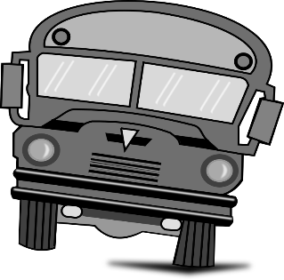
Need to apply for – or amend - an immigration document?*

Take the Greyhound Bus to the Border!
*Please consult the ISS website to ensure that you are eligible.
There are TWO borders close to Montreal. Both will be able to help you with immigration documents, but the departure times (and number of buses per day) varies. Choose the one that makes the most sense for you.
- Lacolle, Quebec & Champlain, New York
- St. Armand/Philipsburg, Quebec & Highgate, Vermont
Purchase your round-trip ticket:
Option #1: ONLINE - on Greyhound.ca (search “US CA” for US border results, and select the option for Vermont/New York)
Option #2: IN PERSON - Meet with an agent at Gare d’autocars de Montreal (1717 rue Berri). Let them know that you need to go to the border on a round-trip visit. Be at the bus station at least 1 hour prior to departure if purchasing your bus ticket in person.
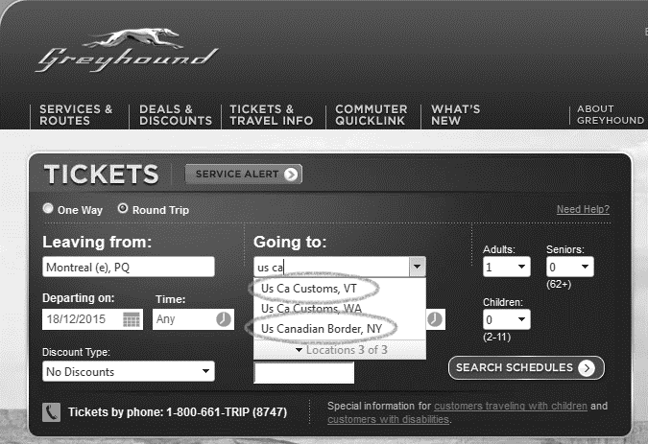

- Given the waiting time for the bus returning to Montreal, we suggest that you bring a good book and / or pack a lunch with you! There is no WiFi at the border.
- Costs and times vary. The above information was obtained in December 2015 and may be subject to changes.
QUESTIONS? Call the bus station - Tel: 514-842- 2281 (press #0 to skip automated message)

