Department of Mining and Materials Engineering

TRACK your new experiment!
Think through the task
Recognize the hazards
Assess the risks
Control the hazards
Keep safety first in all tasks

- THINK through the task
Name:
Supervisor:
Date:
Experiment title

Objective

Accurate description of the experimental procedure (please include all steps, amounts of materials involved, concentrations of solutions, temperatures, times…)

- RECOGNIZE the hazards
Which hazards do you deal with in your experiment?
Please go through the list below, using this table in order to evaluate if your risk is low, moderate or high:
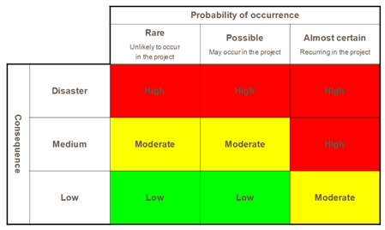

Risk | Low | Moderate | High
Flammable gases, liquids or solids
Toxic and/or corrosive gases, liquids or solids
Oxidant gases, liquids or solids
High temperature liquid metal
High or low Temperatures
High pressures or reduced pressures (vacuum)
Electromagnetic interference or high energy laser
Steam
Radioactive substances
Voltages >115 V or Currents >15 amps
Pathogenic organisms
High speed rotating Machinery
Dangerous chemical reactions
Other hazards

- ASSESS the risk and CONTROL the hazard
For each of the risks checked above as either moderate or severe, explain the potential bad consequences and explain the measure you have used to control them. If you describe something related to a hazardous material, explain also where you store and how you dispose of the material.
(see first line as an example)

Risk | Description of risk | Associated hazards | Actions taken to control risk | Storage and disposal
Corrosive liquid | Use concentrated HCl when preparing HCl 0.1 M solution | Burns from exposure to concentrated HCl on skin, or through vapors; highly reactive with water and bases. | - Work under fume hood  - Wear gloves, lab coats, goggles  - Appropriate storage and disposal  - Careful handling of container | - Store with acids in ventilated cabinets under fume hood  - Dispose in acid container after dilution

- KEEP safety first in all tasks
Keep this form in your lab notebook and have it handy when you do your experiment. Put in action the safety measures you have planned on. Fill another form if you are starting a new series of experiments.
Show this form to your supervisor and have him/her challenge you on what you have written here!

