Final Report
Mac Permaculture Classes Project

From the Mac Permaculture Guild
Represented by Lorine Dargazanli and Faan Rossouw

For the Sustainable Project Fund

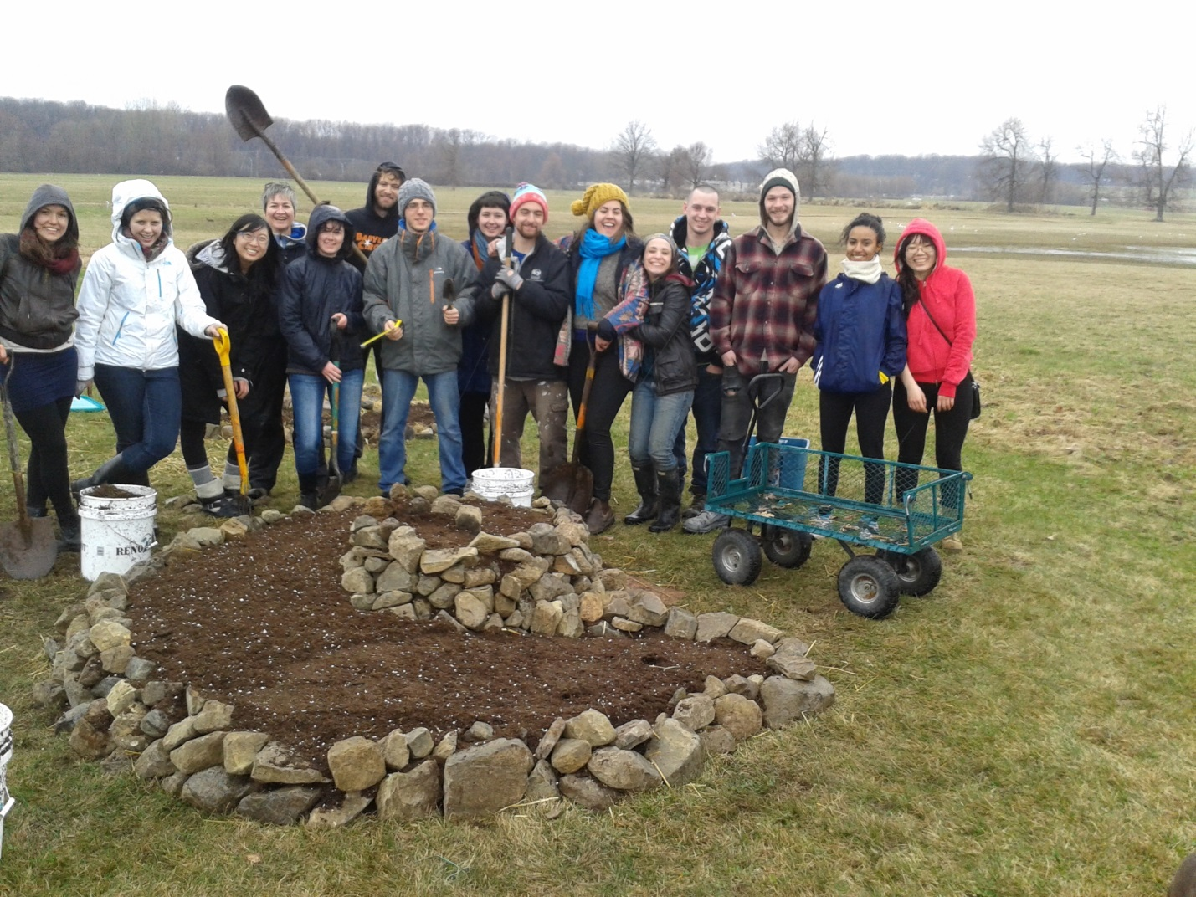
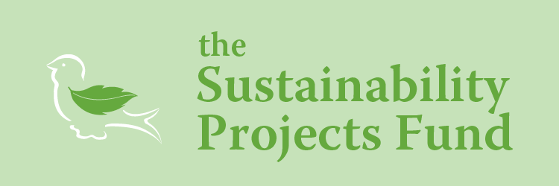
19 March 2015

• Summary of the project

The Permaculture Classes project at Mac aimed at promoting permaculture education within McGill community through the creation of permaculture classes at Mac Campus, on alternative Saturdays in the Winter semester 2014. Throughout 8 sessions, students had the opportunity to discover the growing movement of permaculture and the projects that are happening in Montreal. The classes were free – on a donation basis – totally funded by the SPF application. The teaching team was composed of students possessing a certificate in permaculture design, academic teachers (from McGill and Permaculture Institutes), and guest speakers presenting their projects and experience, in the area of Montreal. Our goal was to connect together the growing community of inspired students at McGill (and especially Mac Campus) fueled by the energy of bringing positive change in our contemporary world. At the end of the semester, participants were offered to volunteer for the creation of a spiral herb garden, for the production of the MacDonald Student run Ecological Garden (MSEG).
• Successes and challenges

Overall the project was a great success: we had an attendance way above our expectations and the large amount of donations allowed us to purchase more material for the spiral garden.

• Directly and indirectly impacted stakeholders

The primary stakeholder targeted was the Mac campus community. The great attendance to the classes (about 30% students), and their participation in the construction of the spiral garden for the MSEG team was a gage of the success of this project at involving the student body. Creating free classes by donation was a true incentive that motivated them to participate since permaculture classes are becoming more and more popular and expensive. We also involved more than expected the Montreal and West Island community, by attracting people beyond the McGill circle and different background. Those included students from John Abbott and other universities, farmers, homesteaders etc…Breaking the bridge between the academic knowledge of agriculture taught at Mac and the reality of the current permaculture movement in the world was one of our goals that we have thus reached.
The positive impacts of our projects were defined according to three criteria; first of all the number of attendees and the creation of a social platform at Mac Campus about permaculture. With an average of 30 participants for each 8 classes facilitated, and a Facebook page counting 400 members, which is as of today still active, are indicators demonstrating our success at reaching to the community. We estimated a total of 100 people educated about permaculture as a global result of all the classes combined. Second, we looked at the number of links created between organizations, participants and teachers. By hosting a broad range of local speakers (from entrepreneurs to non-profit organizations) we effectively represented the permaculture movement specifically in the region of Montreal. Several informal links between the participants and the speakers were also made through the creation of volunteering, internship or project opportunities. Five main organizations were introduced to the students: Garden Without Boarders (NGO), Miracle Farm (commercial permaculture farm), P3 Permaculture (social business), Wen Rolland (private consultant) and ***. A major project initiated as a result of those connections is the collaboration between P3 Permaculture and the Mac Permaculture Guild to create a Permaculture Certification program with McGill students in winter 2015. Lastly, a concrete outcome of the project was the creation of three spirals gardens designed by some participants of the class and members from the MSEG team. Those spirals, planted with aromatic herbs, supported another student project funded by SPF (the Druids) to produce spiced and tea for the Mac community. Indeed, the connection and collaboration with other student organizations (MSEG and the Druids) was another positive result from this project.

• Changes in budget, if any compared to the original budget

The budget was respected as planned and the donations generated were used to supply material for the final design exercise (paper, color pencils, stickers…)

• What is next for this project

To further spread the permaculture movement at Mac, we want to create a food forest as a demonstration garden of the permaculture techniques used in agriculture. For this we would need some students to get the permaculture certification in order to be able to design it. We hope that this food forest will become an educational tool for classes on campus and eventually a food source for the different cafeterias.

• Ownership plan

Lorine Dargazanli who supported the organization of the classes, will stay in communication with P3 Permaculture to organize the permaculture certification project.

• Recommendations for the future of this project

The barrier between permaculture and the student body only comes from the financial side: while already paying for education at university, students are reluctant at additionally paying for permaculture instruction. Making this as affordable as possible is thus the major factor we see to successfully grow the permaculture interest at Mac.

• Success and challenges from a project planning and management perspective

Having only two coordinators made all decisions and tasks accomplishments very easy.

• Lessons learned from a project’s planning and management perspective

The organization of the classes was very straight forward thus we didn’t face specific challenges from a management perspective. Collaboration in advance with other students group is something important to take into account to create strong links with them.

